**DEPARTMENT OF COMPUTER SCIENCE**

**FACULTY OF SCIENCE UNIVERSITY OF JAFFNA**

**PIGEONN – THE COMMUNITY PLATFORM**

**Submitted in partial fulfilment of requirements for the course unit**

**CSC314GC2**

**TEAM MEMBERS**

* **K. S. Subhashana Silva 2015/SP/148**
* **Nisal Shaminda 2015/SP/189**
* **S. Anusa 2015/SP/007**
* **M. Suhirthashini 2015/SP/157**
* **W. G. A. B. Chandrasena 2015/SP/280**
* **J. Vithurshan 2015/SP/168**
* **V. Pakeesan 2015/SP/204**

# Executive Summary

## Objective of the project

Problems arise in the technologies now. There should be a perfect technician to solve all these problems. But it’s difficult to find a suitable person to solve the problems immediately.

So Pigeonn application helps people to connect with the technicians to solve the problems immediately and to get more knowledge about the technology.

Thus, this report extensively includes all the details of this application and the functions, services, availability, and the scope of it.

*This study, conducted by Jaffna Computer Science Faculty Students, looks at both pre-contractual and contractual matters concerning Pigeonn, examines relevant Community rules, identifies gaps and, where needed, discusses possible policy options.*

## Customer

The real world is our customer. The technicians who can solve the technical problems and the people who have technical issues are the customers.

## Problem statement

Errors in the application while working in the android studio. Version problems.

## Proposed solution

* + Setting up the same SDK levels while working.
  + Fixing the errors when uploading and downloading the project from GitHub.
  + Finding the ways to avoid from errors in android studio.
  + Updating and downloading the APIs and components that are needed for android studio.

# Team members and their roles

1. **K. S. Subhashana Silva - 2015/SP/148 (Project Leader)**
   * Create the project in Android Studio and Create the project in firebase and connected to the Android project, upload the initials the github repository. Add validations on Main page and Start Page, Created Login Page and the Register Page, Toolbar and register new users and send their data to the firebase database. Created notification function, and Fixed errors take the app working state.
2. **Nisal Shaminda - 2015/SP/189**

* Finished retrieving friend requests from database for users.Finished the part respond to the friend’s request. Part of disappear from request panel and add as a friend. And or when press cancel, it automatically cancels. Finished the part of storing pictures that transmit when chatting in firebase. Part of sending and viewing chat images. Sending and receiving messages and make it it beautiful. And also done and fixed lots of errors and work with collaborate with others.

1. **S. Anusa - 2015/SP/007**

* Finished doing login part of the user. Completed the sections such as the settings activity and the UI design of the settings activity, saving user data in firebase database, retrieving user data from database, cropping image, setting user online status, alerting dialog for sending message, last seen of the user, and saving message data in the firebase. Prepared 5 survey questions. Worked with the errors. Helped others to do their works.

1. **M. Suhirthashini - 2015/SP/157**

* Finished doing the part about the existing friend and making the friend unfriend. Completed firebase off, declining friend request, getting the notification of the firebase, sending friend request notification, receiving notifications, pushing notification to the firebase and displaying user friend. Worked with the errors. Helped others.

1. **W. G. A. B. Chandrasena - 2015/SP/280**

* Completed the sections such as storing images into the firebase, retrieving profile image from the firebase, changing user profile status, creating all user’s activity, displaying layouts of all users, retrieving and displaying all user’s profile, and defaulting profile validation. Helped others to do their works. Worked with the errors.

1. **J. Vithurshan - 2015/SP/168**

* Retrieved and displayed user message. And did one to one chat application. And the parts like requirements fragment and displaying friend request. Helped others to their work.

1. **V. Pakeesan - 2015/SP/204**

* Completed the parts compressing thumb image and uploading it to firebase, displaying thumb images, profile activity, visiting user profiles, sending a friend request to a person, cancelling the friend request and accepting friend request. Worked with the errors. Helped others.

# Software Details

Name - PIGEONN – THE COMMUNITY PLATFORM

Version – v1.0.0

## Licence – Google play license

# How to install – As usual Android app installation

# Explain the flow using your Graphical User Interface.

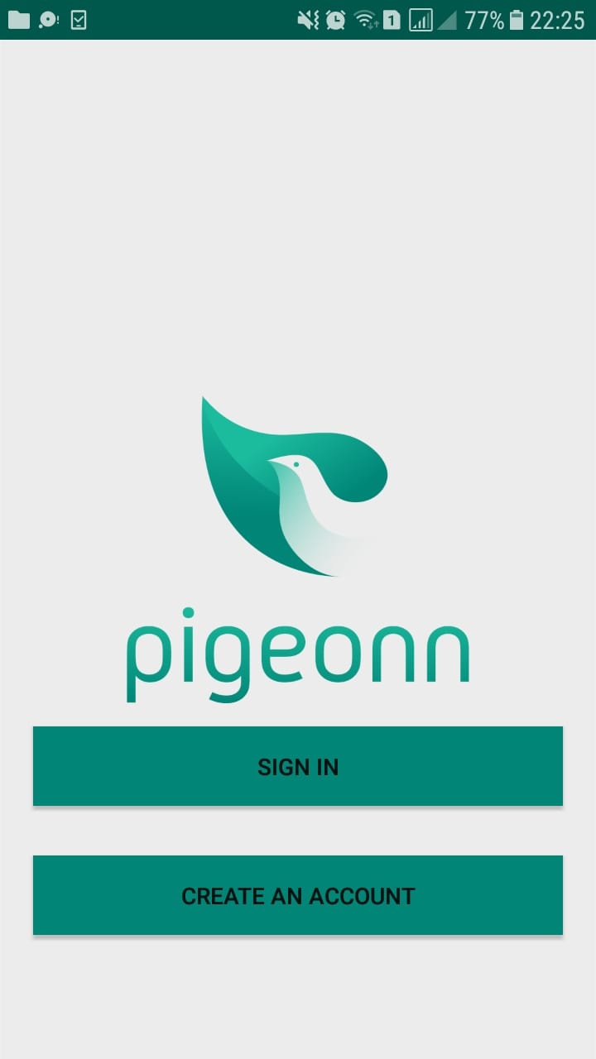

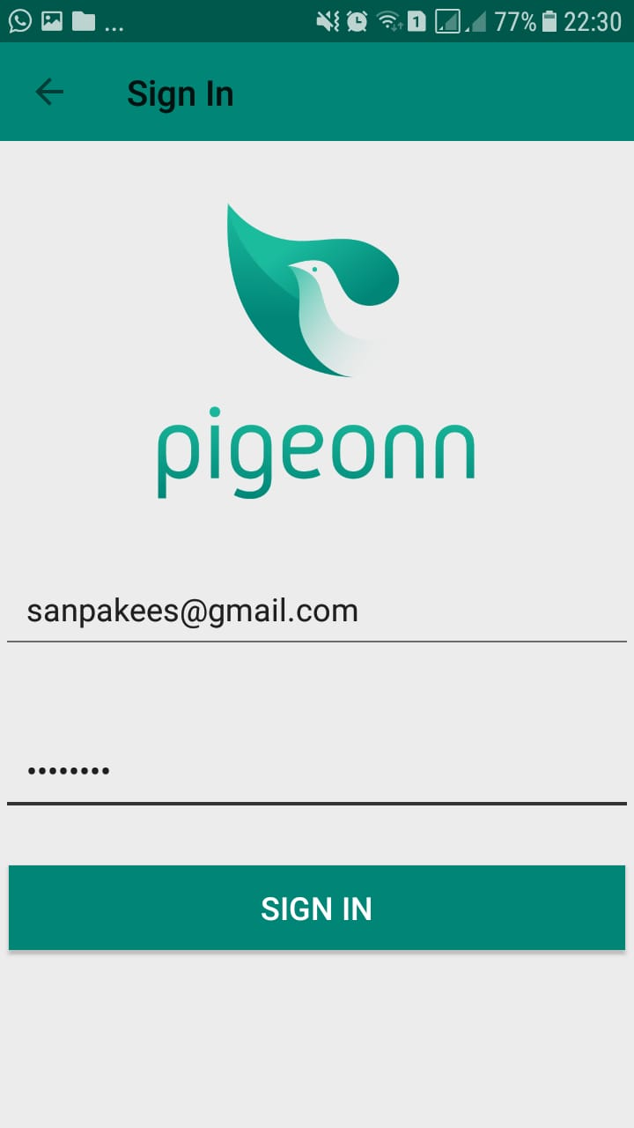

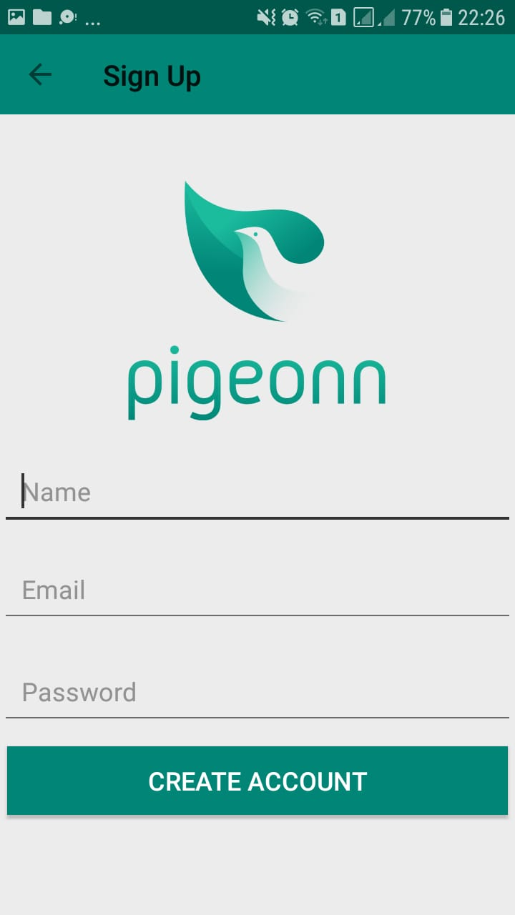



**More Information -** https://github.com/SHalintHa/Pigeonn